Transformer
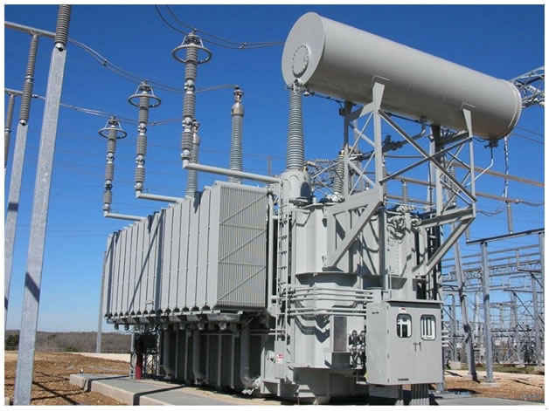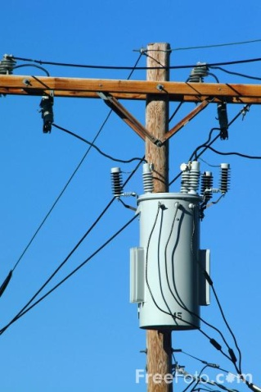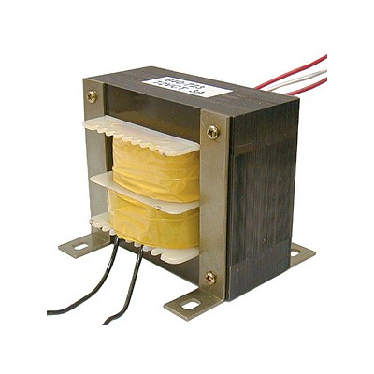

A transformer converts AC at one voltage/current to another. It will not work on DC.
Power is input to the PRIMARY coil.
Power is output at the secondary coil.
Vp = Primary voltage Ip = Primary current
Vs = Secondary Voltage Is = Secondary Current
Np = Number of turns of wire in the primary
Ns = Number of turns of wire in the secondary
Transformer Relations (assuming 100% efficient transformer)
Vp/Vs = Np/Ns
(Vp)*(Ip) = (Vs)*(Is)

Using a transformer to improve the efficiency of electrical transmission

Assume that a residence uses 70.0 Amps at 117 Volts. The wire to the power plant has a total resistance of 85 Ohms.
1. How many Volts will be dropped in the wire?
2. How many volts must be supplied by the power station?
3. Calculate the power consumed by the house.
4. Calculate the power generated at the station.
5. Calculate the efficiency of this method of supply (power used / power generated)?

Now assume the power to the house is supplied by a local transformer which has a primary of 34.5 kV.
6. How much current will flow in the 34.5 kV side of the transformer?
7. What will be the voltage lost in the wire from the station to the transformer?
8. How much voltage must the generator provide so that exactly 34.5 kV reaches the transformer?
9. How much power is generated by the generator?
10. How much power is used by the house?
11. Calculate the efficiency of this method of supply (power used/power generated)?

