Collisions and Explosions:
Main idea: In an isolated system (no external forces) there can be no NET impulse. If there is no impulse then there is no change in momentum. Therefore the total (vector) momentum of the system is constant.
Law of CONSERVATION OF MOMENTUM
Total momentum before = Total momentum after
Conservation of momentum problems:
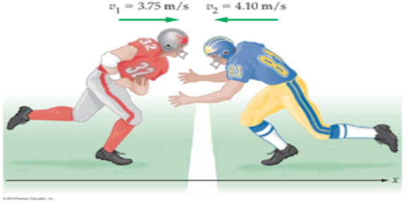 1. On a touchdown attempt a 95 kg running back runs toward the end zone at 3.75 m/s. A 111 kg linebacker moving at 4.1 m/s meets the runner in a head-on collision. If the two players stick together, what is their velocity immediately after the collision?

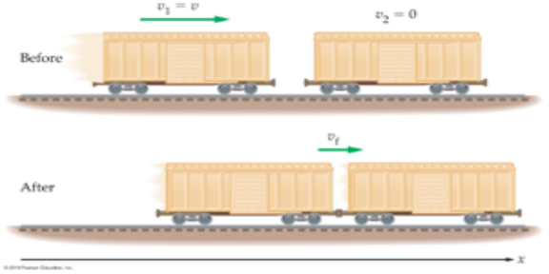2. Two railroad cars collide. One, having mass m and moving at velocity v₁ to the right hits an identical car which is not moving. After the collision they lock and move together at velocity v_{f} . How does v_{f} compare to v₁?

3. A 1200 kg car moving at 2.5 m/s is struck directly from behind by a 2600 kg truck moving at 6.2 m/s. If the vehicles stick together after the collision, what is their speed immediately after colliding? (Assume external forces can be ignored! No Friction.)

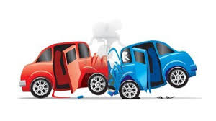 4. At a busy intersection a 1540 kilogram car traveling west at 12 m/s collides head-on with a minivan traveling east at 9.4 m/s. They stick together and move with an initial velocity of 1.5 m/s to the east after the collision. What is the mass of the minivan?

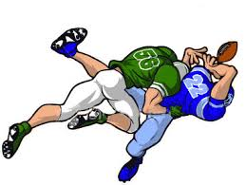5. A 95 kg (209 lb) fullback running at 8.2 m/s collides in midair with a 128 kg (282 lb) defensive tackle moving in the opposite direction. Both players end up with zero speed. How fast was the
defensive tackle moving originally?
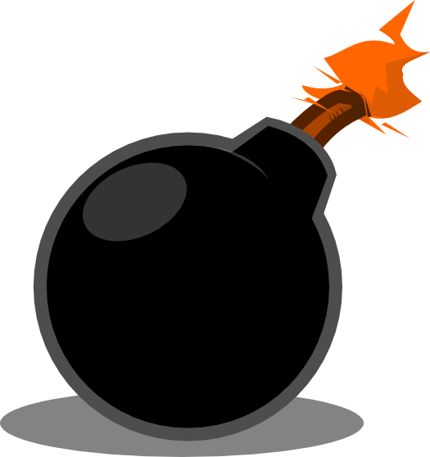6. A small bomb has a mass of 2.3 kilograms. It explodes into two fragments. One fragment has a mass of 1.8 kilograms and moves at 35 m/s toward the West. What is the velocity of the other fragment?

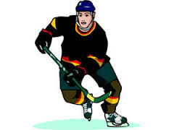7. A 70 kilogram hockey player is moving at 25 m/s toward the right when he collides with another player who is moving toward the left directly toward him at 25 m/s. Immediately after the collision they are both moving to the left at 3.0 m/s. What is the mass of the other player?

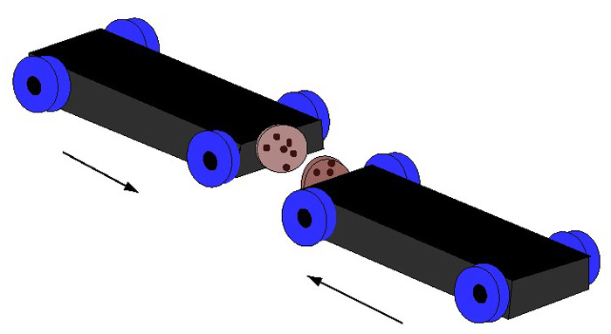8. Two lab carts are pushed together with a spring mechanism compressed between them. Upon release, the 5.0 kg cart repels one way with a velocity of 0.12 m/s, while the 2.0 kg cart goes in the opposite direction. What is the velocity of the 2.0 kg cart?

9. A rifle has a mass of 4.1 kilograms. The bullet has a mass of 2.6 grams When the gun is fired the bullet leaves the gun with a velocity of 612 m/s. What is the recoil speed of the gun?

