Preview # 5 Graphing motion

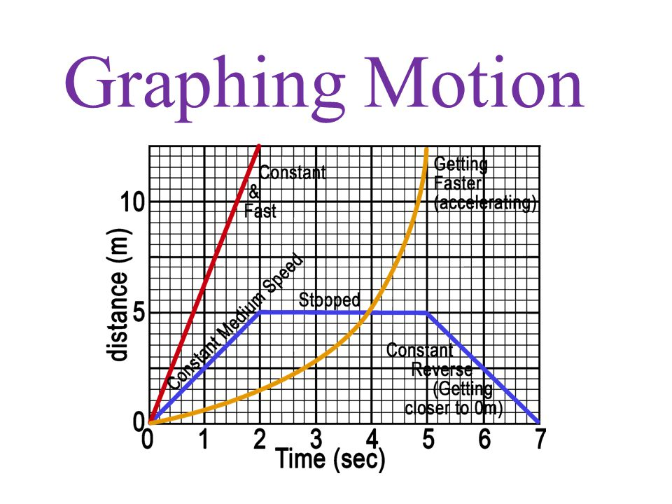

Go to http://ionaphysics.org/classroom/Physlets2/IonaPuzzles/Car4/Car4.html

Read the instructions. You will see a car moving. You can control its motion by moving the cursor into and out of the frame.

Stop the animation as many times as necessary and record the time and the location of the car.
Draw a graph of the motion of the car (time on x-axis and distance on the y-axis) for the entire 100 seconds of the animation.

Your report should include a data table and the graph of the motion.

