Electrostatics 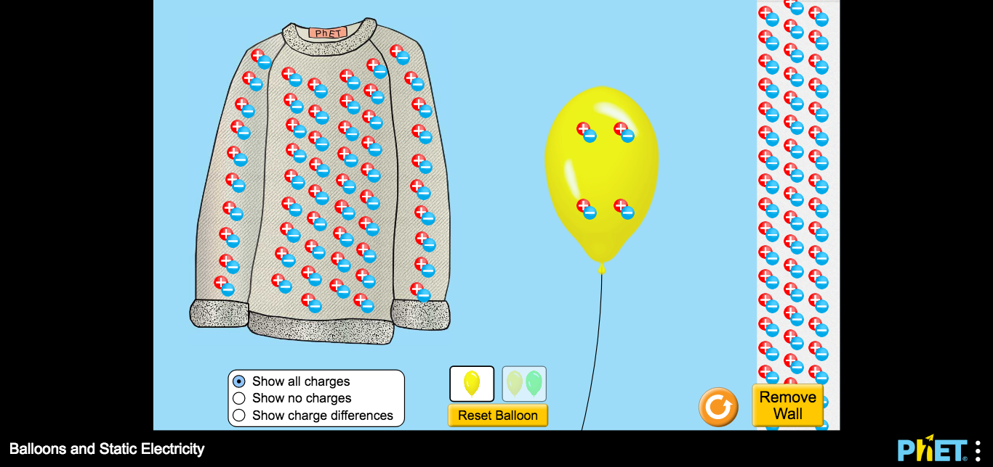

- Go to https://phet.colorado.edu/sims/html/balloons-and-static-electricity/latest/balloons-and-static-electricity_en.html
- Observe the fact that you have a balloon, a sweater, and a wall. The charges (normally invisible) are indicated. At this point the sweater is (charged positively, charged negatively, not charged).
- The wall is (charged positively, charged negatively, not charged).
- The balloon is (charged positively, charged negatively, not charged).
- Now drag the balloon over until it is near, but not touching, the wall. What happens? __________________
- Now rub the balloon on the sweater. What is the charge on the balloon now? (charged positively, charged negatively, not charged).
- What is the charge on the sweater now? (charged positively, charged negatively, not charged).
- What you just observed is called “conservation of charge”, charge is not created or destroyed, but it is moved around.
- Drag he charged balloon until it is about halfway between the wall and the sweater. Describe what happens when you release it.____________________________
- Now drag the balloon over near the wall. What do you observe?______________________________________________
- What happened to the charge on the WALL? __________________________________________________________
- What you observed in step 11 was that the charge on the wall remained neutral (no charge was gained or lost), but it separated a bit. That is called polarization. That put the positive charge slightly closer to the sweater than the negative charge. The balloon was (attracted, repelled) from the wall.
- Opposite charges (like the positive sweater and the negative balloon (attract, repel) each other.
- A charged object may be attracted to a neutral object (True, False).

Name ___________________________________Period _______________
Electrostatics Answers:

Answers:
- (charged positively, charged negatively, not charged).
- (charged positively, charged negatively, not charged).
- (charged positively, charged negatively, not charged).
- What happens? __________________
- (charged positively, charged negatively, not charged).
- (charged positively, charged negatively, not charged).

- Describe what happens when you release it.____________________________
- What do you observe?________________________________
- What happened to the charge on the WALL? __________________________________________________________
- (attracted, repelled) from the wall.
- (attract, repel) each other.
- (True, False).

