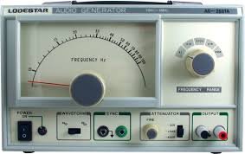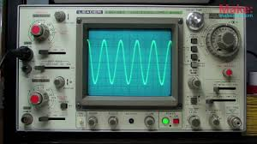

Assignment: Play with an audio oscillator and an oscilloscope.
In this activity you will play with an audio oscillator (sometimes called a tone generator) which is attached to a very simple oscilloscope.
Go to Sine wave generator and oscilloscope
The tone generator is on the left, the oscilloscope on the right. Click the tone generator’s “Speaker On” button to make the signal play through your computer speakers. You can control the volume of the signal using the slider at the bottom of the Tone Generator panel.
Observe the signal on the oscilloscope.
Increase the frequency on the tone generator and observe the effect it has on the oscilloscope trace.
Move the Amplitude slider on the oscilloscope and observe the effect it has on the trace.
Questions:
- What is an oscillator?
- What is an oscilloscope?
- What is the effect on the oscilloscope trace when you increase the frequency of the oscillator?
- What is the effect on the oscilloscope trace when you increase the amplitude of the trace?
- If you increase the frequency of the tone, what happens to the wavelength of the trace?

