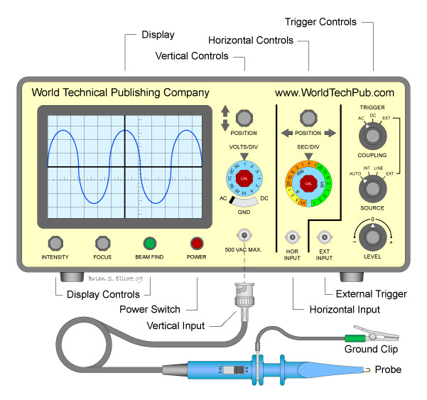
Virtual Oscilloscope Lab: V.2.1

An oscilloscope is a piece of electronic test instrument. It provides a graphical display of a varying voltage. The voltage may represent almost anything which can be converted to a voltage. For example, light can be detected by a phototransistor and its intensity converted to a voltage. Sound can be detected by a microphone and converted to a varying voltage. Electrical signals in almost any circuit can be directly measured and displayed on an oscilloscope. It is a very useful diagnostic tool, when you get skilled with using it.

Being able to “see” a signal gives much more information than a voltmeter or ammeter.

A good oscilloscope can be quite expensive, but a simple (and limited) one is available online for free! The device we will be using will be limited by the programming, as well as the speed, precision, and sensitivity of the circuits and sensors in your computer.

Click on this link (or copy it and paste it into another tab) to get the online oscilloscope:
https://academo.org/demos/virtual-oscilloscope/

Note that several inputs are provided: Sine wave, Square Wave, and live input.
1. Choose the sine wave input and set the input wave frequency to 500 Hz
2. Adjust the oscilloscope gain so you can see a nice sine wave on the screen.
3. Adjust the seconds/division to 1 ms. (1 ms = 0.001 second). That means each horizontal division is 1 ms. Since you have a 500 Hz signal, the period would be 1/500 sec or 0.002 seconds. Note that the complete sine wave occupies 2 horizontal divisions or 2 ms. That should make sense.
4. Predict: If you were to increase the frequency to 1 kHz (1000 Hz) what would you predict would happen to the pattern on the screen?
5. Now set the input frequency to 1 kHz. Describe the pattern
6. Now switch the input to live input (make sure the “freeze live input” box is NOT checked.)
Now you will see a trace representing the random ambient sounds.
7. Using your phone, start Phyphox and choose the tone generator. Set the frequency to 1000 Hz. Turn it on and when you have a good pattern, click the “freeze live input” box. (A) Describe what you see. (B) Does this frequency look about the same as the frequency in step 5?
8. Now change the frequency on Phyphox to 2000 Hz. Again start the Phyphox sound. Uncheck the “Freeze input” box and when you get a good trace, check the “freeze input box.
9. How does the trace of the 2000 Hz signal differ from the 1000 Hz signal?
10. Do you see how this device would let you measure an unknown frequency?

Answers to questions:
Step 4:
Step 5:
Step 7 A:
Step 7 B:
Step 9:
Step 10:

