Iona Preparatory School Science Department
Physics Experiment: To measure the mechanical advantage of several Pulley systems.
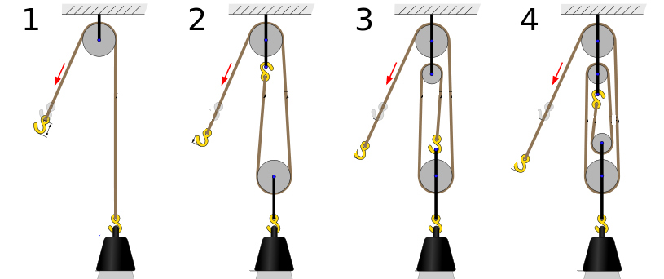
Getting work done sometimes involves the use of simple machines. Simple machines may be used to:
- Change the direction of a force
- Multiply the force (while dividing the distance)
- Multiply the distance (while dividing the force)

Since energy cannot be created or destroyed, and since some work is expended overcoming friction, the actual work output of a simple machine is ALWAYS less than the work input. However, a simple machine can make it easier to do work which would otherwise be extremely difficult, or impossible.

One example of a simple machine is the pulley. We will be using pulleys to change the direction of a force and also to multiply the amount of force (while dividing the distance). We will calculate the mechanical advantage of each setup.
Software Procedure:
- Connect the Force sensor to the Air link.
- Launch SparkVue and pair it with the Air link.
- Choose 2 Large Digits as the display. (You will actually use only one of the displays).
- Click on “Select Measurement” and choose Force (N) from the list.
- Click “Record” in order to view the reading of the Force Sensor.
- Click “Zero” on the force sensor to calibrate it. This is very important!
- During this experiment you record ALL forces as positive.
- Click “Stop” to stop the force sensor activity.

Experimental Procedure:
- Use the Force Sensor to determine the weight of the mass you are using. This will be the “Resistance” in all of the following experiments.
- Set up the system of diagram 1. Zero the sensor and then measure the force necessary to move the mass upward SLOWLY without accelerating it.
- Set up the system of diagram 2. Zero the sensor and then measure the force necessary to move the mass upward SLOWLY without accelerating it.
- Set up the system of diagram 3. Zero the sensor and then measure the force necessary to move the mass upward SLOWLY without accelerating it.
- Set up the system of diagram 4. Zero the sensor and then measure the force necessary to move the mass upward SLOWLY without accelerating it.
- Calculate the Mechanical Advantage for each of the setups.
Diagram | Resistance (N) | Effort (N) | Mechanical Advantage (R/E)
1
2
3
4

OPTIONAL EXTENSION:
Measure the Effort Distance and Resistance Distance. Calculate the work input and work output and calculate the efficiency of each of those systems.

Diagram | Resistance (N) | Effort (N) | Effort Dist (m) | Resistance Dist (m) | Work In  E * ED (J) | Work Out R*RD (J) | Efficiency  Work out/work in
1
2
3
4

A note about significant figures:
Record exactly what the probe reports for the Resistance and Effort. If necessary, review information about significant figures before you record the mechanical advantage.

If you do the extension, effort distance, resistance distance, work in, work out, and efficiency should all be recorded using the proper number of significant figures.

