Iona Preparatory School Science Department
Lab: To Determine How the Period of a Pendulum Depends upon its Length

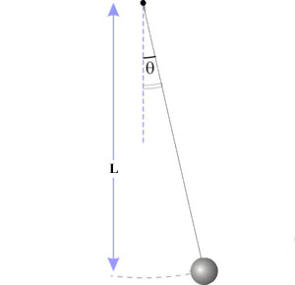
The Length of the pendulum is measured from the support point to the center of the bob.
Abstract:
In this experiment you measure the period of a pendulum at various different lengths. After that you look for a mathematical relationship between the length and the period.
1. Measure the length of the pendulum.
2. Time 50 periods and divide that by 50 to get the length of a single period.
3. Repeat the procedure for each pendulum lengths NEAR each of those listed below. The actual length of your pendulum will probably be slightly different. Change the lengths in the data table to reflect the actual lengths you used. Lengths should be recorded to the nearest 0.1 cm. Take a picture of the apparatus as it is set up to use in your lab report.
Length (cm) | Period (s)
10
15
20
25
30
35
40
45
50

Here is a link to a form for you to submit your data so the whole class set of data can be collected.
https://docs.google.com/forms/d/1KXNgu9Y6ihdVSCDEnGq0iC4rtRQIYuLjYxWV0ydUGW4/viewform?usp=send_form

