Project: To determine the Mass of the Earth

Name: _________________________________________

Sir Isaac Newton (1643-1727) proposed that the force of gravity between any two masses (m1 and m2) is proportional to the product of the masses and inversely proportional to the square of the separation between them.
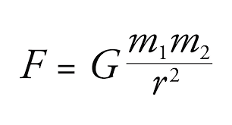
F is the force of gravity
G is the Universal Gravitational Constant, m1 and m2 are the masses, r is the separation between them.

Henry Cavendish performed an experiment in 1797 or 1798 which determined the value of the Universal Gravitational Constant.
G = 6.67 x10^-11 N m^2/kg^2

Consider yourself standing on the earth. You can use your mass, your weight, and the known radius of the earth to determine the mass of the earth!

- Measure your weight (in Newtons) using the force plate.
- Calculate your mass in kilograms by using the equation W = mg. That will be m1
- At this point we do not know the mass of the earth. Solve the Universal Gravitational equation (above) for the unknown mass of the earth m2.
- The distance between you and the earth is really the radius of the earth. Use some reference material to find the average radius of the earth.
- Substitute your weight, your mass, the gravitational constant, and the radius of the earth into the equation and calculate the mass of the earth.
- Find the accepted value for the mass of the earth and calculate the percentage difference between your value and the accepted value for the mass of the earth.
Data:
My weight ______________________________Newtons

My mass ______________________________ kilograms

Radius of the earth (from reference) _____________________________meters

Conclusion: Mass of the earth = ___________________________kg

% difference = ______________________________

