Iona Preparatory Science Department - Physics Lab

To measure the acceleration of gravity using an inclined plane and Capstone

You will use an accelerometer to measure the acceleration of gravity. It would seem easy to do this by simply dropping the accelerometer. However it would not be easy to assure the accelerometer did not rotate, thus spoiling the measurement. It also would be difficult to avoid damaging the accelerometer.

We will use an inclined plane to “dilute” gravity. We will fix the accelerometer to a low-friction cart.

Diagram:
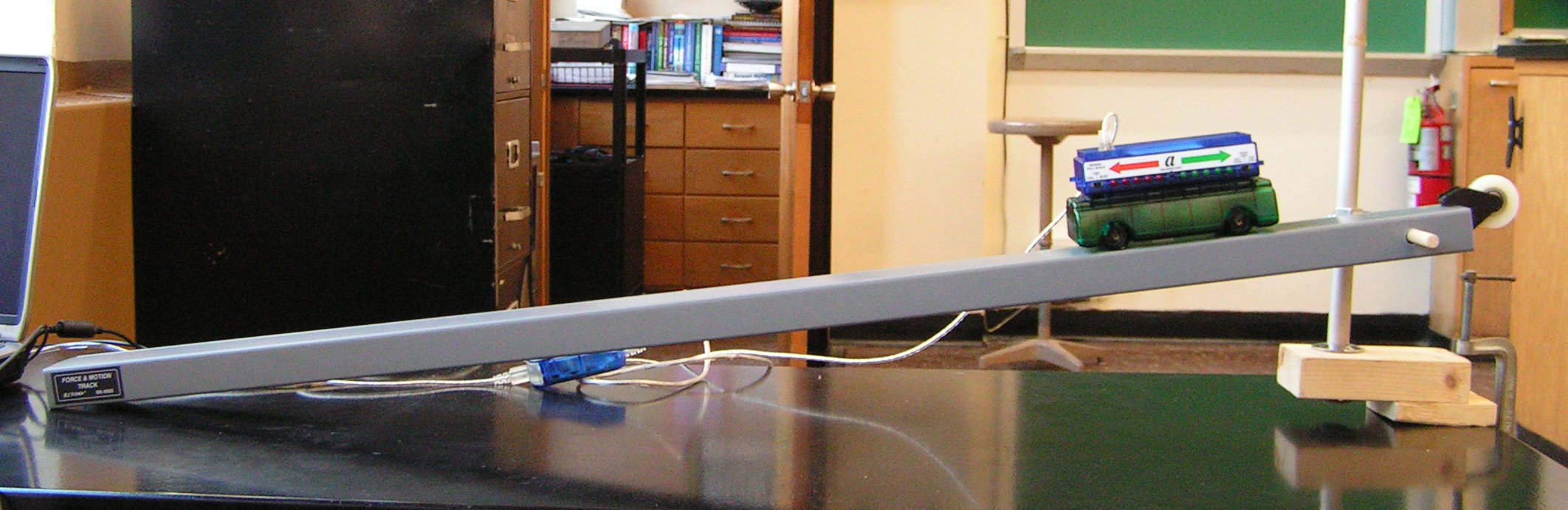

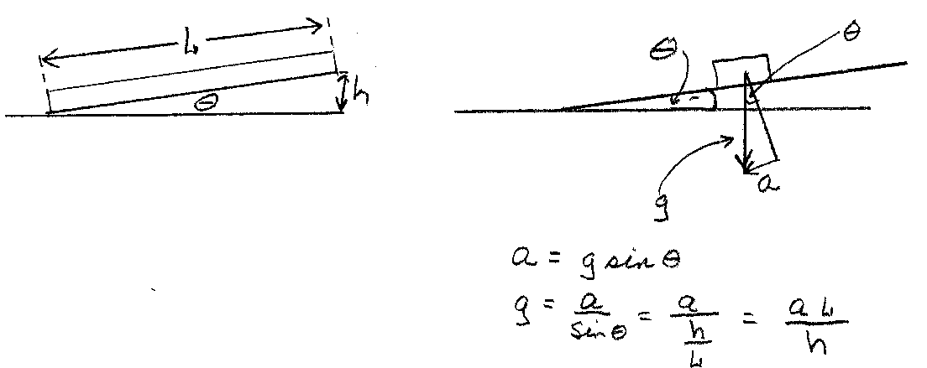
Support Detail: 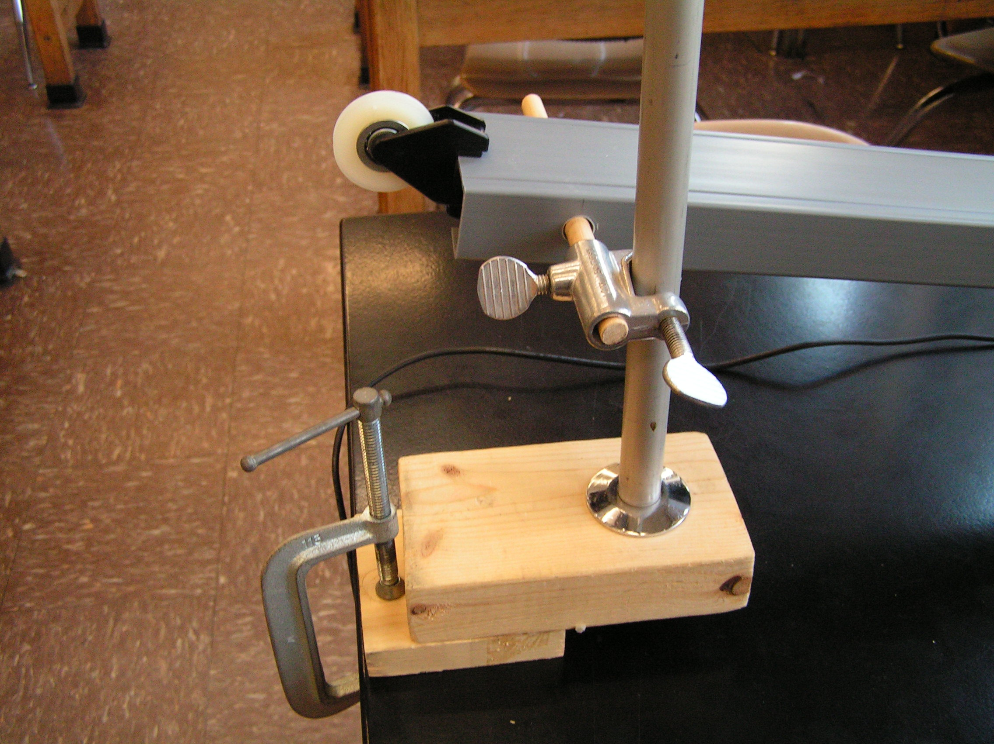
Procedure:
- Set up the inclined plane at a very low angle.
- Attach the accelerometer to the low friction cart.
- If your accelerometer is the one pictured, then set the Left switch to “Auto Scale”
- Attach the USB link to the computer.
- Run CAPSTONE
- Choose Table and graph. On the Y axis of the graph click on “Select Measurement” then click on “Acceleration m/s”.
- Measure L, the length of the inclined plane. Record that in the data table below.

For each data run:
- Measure h, the height of the end of the plane above the table. Record it in meters.
- Place the cart on the plane and zero the accelerometer by pushing the small black button on the accelerometer. (You must zero the Accelerometer before EACH run.) (To zero the 2-axis accelerometer there is a button on CAPSTONE itself.)
- Press START on capstone.
- Let the cart accelerate down the plane. Take care to reduce friction as much as possible by holding the Accelerometer cable.
- Catch the accelerometer at the bottom! Do not let it crash into the table or run off the table.
- Press STOP on Capstone.
- Expand the scale of the graph and record the acceleration of the car.
- Use “Delete last run” before doing another run.
- Repeat for several different values of h, recording your values in the table below.
- When you are finished collecting data, disconnect the accelerometer from the computer and press the black button, holding it until two red and two green LEDs are lighted, then release the button. This turns off the Accelerometer.
Data analysis:

L = ____________________
h (m) | a (m/s^2) | g = a*L/h (m/s^2)
Calculate the average value for the acceleration of gravity

Conclusion:
The acceleration of gravity was found to be …

Report your data here: https://docs.google.com/forms/d/1LOaQjg0eoPJXoBUTeY7kfsiyK542DID7IY7FVsJw88c/viewform?usp=send_form

