Iona Physics Lab Title: Find the force
The simulation is located here https://ionaphysics.org/classroom/Physlets2/IonaPuzzles/Force/FindTheForce.html
Introduction:
The simulation shows a box being pushed by a hand. It is accelerating from left to right. Your job is to find the magnitude of the acceleration.
We will do the first part (deriving an equation) together in class. After that you will make measurements at multiple points along the path, calculate the acceleration at each of those points, and then draw any conclusions you can from your data.
Significant Figures:
In this case you cannot do better than 2 significant figures. So, keep 3 figures when you are doing your arithmetic and round off to two figures when calculating the force.
Diagram: A screen shot will be sufficient.
Procedure:
- Derive the necessary equations. (Show them!)
- Create a data table. You may use a Spreadsheet OR simply make a table and do all the arithmetic by hand. Hint: using a spreadsheet is easier!
- Run the simulation, stopping it at 10 different points to take measurements and enter the data into your spreadsheet or data table.
- Your data table should look like this:
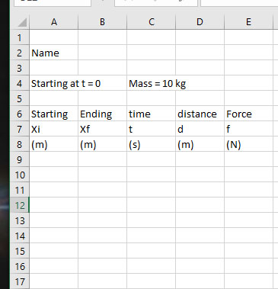
- Conclusion: Answer the following questions:
- What is the average force exerted on the box?
- Did it seem to be fairly uniform throughout the run?
- If it was NOT fairly uniform throughout the run, and if it had a clear pattern, where was it greatest and where was it least?

